

**Course Name**: COMPUTER ARCHIT LAB

**Course Number and Section**: 14:332:333:02

**Experiment**: Lab 2 Pre Lab Report

**Lab Instructor**: Haolin Jiang

**Date Performed**: 3/4/25

**Date Submitted**: 3/4/25

**Submitted by**: Chance Reyes 225006531

**Course Name**: _________________

**Course Number and Section**: **14:332:xxx:xx**

**! Important: Please include this page in your report if the submission is a paper submission. For electronic submission (email or Canvas) please omit this page.**

--------------------------For Lab Instructor Use ONLY--------------------------

GRADE: _______________

COMMENTS:

Electrical and Computer Engineering Department

School of Engineering

Exercise 1 Variable, Operator, and Control Flow [10 pts]

1. [2 pts] What is the output of the program? Please provide a screenshot of the outputA screenshot of a computer

   AI-generated content may be incorrect.
2. [4 pts] Please adjust only the initial values of v0, v1, v2, v3, and v4 to yield the desired output  
   below. Please: (1) list the values of v0, v1, v2, v3, and v4 in your report; (2) Your report should include  
   a screenshot of your program's output.

**v0 = 5, v1 = 5, v2 = 3, v3 = 0, v4 = 1;**

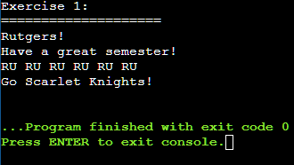

1. After this line, please answer the values of v0, v1, v2, and v3 and explain. If you prefer, you may also  
   test the program to validate your answer.

**The line checks for if v0 > 0. Since this is true, v1 decrements by 1 to 4, v2 increments by 1 to 3, and v3 stays the same.**

**Exercise 2 Program Debug [20 pts]**

1. [2 pts] Please run the program using the Online GDB C Compiler. What is the output of Alex’s program? Does the output align with Alex's expected results?

**The output is num = 20. This does not align with the expected results.**

1. [4 pts] What is the gdb command to set a breakpoint at line 9 (for (int i = 1; i <= 5; i++) {)? What is the gdb command to run the program? You may need to refer to the GDB reference card(You can find the GDB reference card in “Canvas - Files”).
   1. **Break 9**
   2. **Run**
2. [14 pts] Please debug the program to make the output align with Alex’s expectations. Please: (1) submit your code (either .c or .cpp format); (2) in your report, attach the screenshot of the program output and explain why you made such modifications.

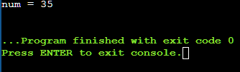

I dereferenced p so that we can directly access num and increment it. I changed the loop boundaries from i<5 to i<=5 so that num correctly outputs 35 instead of stopping at 30.

Exercise 3 Array and Pointers [15 pts]

1. [5 pts] Please list the values of elements in array arr after line 7 (*pointer = 27;) and explain.

**arr[10] = {10, 15, 20, 27, 7, 34, 40, 45, 50, 55};**

**The pointer starts at arr[3] and changes it to 27. Then it increments to arr[4] and changes it to 30-23 = 7. Lastly it increments to arr[7] and changes it to 45-11=34.**

1. 3. [5 pts] Please list the values of elements in array arr after line 11  
   (*pointer = (*(pointer+2)) - 11;and explain.

**The value of the elements are undefined since the memory allocated to the array is deallocated when the function finishes running.**

Exercise 4 Functions [15 pts]

1. [20 pts] Please write a C program to compute the factorial of an input integer x: (x) = x! = x ∗ (x ― 1) ∗ (x ― 2) ∗ ... ∗ 2 ∗ 1

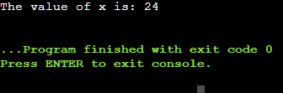

1. [35 pts] Please write a C program to find the largest element in a given array. Your code must have a main() function and a max() function.